**Project Report**

**ParaBank Automation**

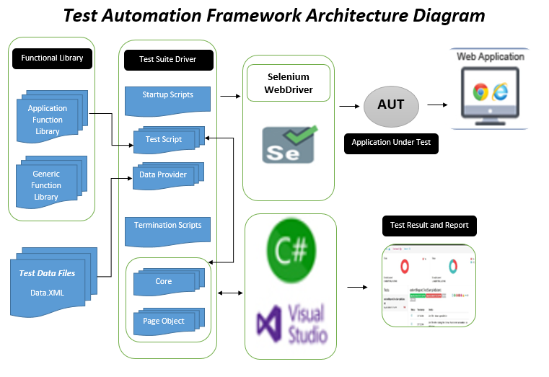

***ParaBank Automation***

**URL:**

<https://parabank.parasoft.com/parabank/index.htm?ConnType=JDBC>

**DataDriven:** Data.xml

**Page Object Model implemented**

**NuGet Packages:**

* Selenium.Webdriver
* Selenium.Support
* Selenium.WebDriver.ChromeDriver
* Selenium.WebDriver.MSEdgeDriver

***Code Explanation:***

**Total Classes**

* **Corepage.cs**

All reusable custom methods that are the need of each page.

All browser Options i.e: Headless or Incognito

**CustomMethods:**

1. SeleniumInit()
2. Write()
3. Click()
4. AssertEqual()
5. SelectDropDownMenu()
6. TakeScreenShot()

* **AccountsOverviewPage.cs**

All the methods that are used in AccountsOverviewTestExecution.cs

Are declared in this class.

**Method:**

1. AccountsOverview()

* **AccountsOverviewTestExecution.cs**

All test methods, test classes, Initialization, cleanups and retrieving data from Data.xml

**Methods:**

1. AccountsOverviewTC_001()

* **OpenNewAccountPage.cs**

All the methods that are used in OpenNewAccountTestExecution.cs

Are declared in this class.

**Methods:**

1. OpenNewAccount()

* **OpenNewAccountTestExecution.cs**

All test methods, test classes, Initialization, cleanups and retrieving data from Data.xml

**Methods:**

1. OpenNewAccountTC_001()

* **RegisterPage.cs**

All the methods that are used in RegisterTestExecution.cs Are declared in this class.

**Methods:**

1. Register()
2. RegisterWithEmptyDetails()
3. RegisterWithCreatedUserDetails()

* **RegisterTestExecution.cs**

All test methods, test classes, Initialization, cleanups and retrieving data from Data.xml

**Methods:**

1. RegisterWithValidDetailsTC_001()
2. RegisterWithEmptyDetailsTC_002()
3. RegisterWithCreatedUserDetailsTC_003()
4. RegisterWithNotMatchPasswordDetailsTC_004()

* **LoginPage.cs**

All the methods that are used in LoginTestExecution.cs Are declared in this class.

**Methods:**

1. Login()
2. LoginWithInvalidDetails()

* **LoginTestExecution.cs**

All test methods, test classes, Initialization, cleanups and retrieving data from Data.xml

**Methods:**

1. LoginWithValidUsernamePasswordDetailsTC_001()
2. LoginWithInvalidUsernamePasswordTC_002()
3. LoginWithEmptyUsernamePasswordTC_003()

* **AppConfig**

1. It contains the browser Option
2. It contains the Url of the Website

***Reporting:***

